Sujay Rao
Dr. Gingrich
Advanced Placement Language and Composition
13 March 2019
Rules for an Orchestral Review
- Have a strong attention-grabbing hook
  - Having a strong hook provides context to your review and “grabs” the reader’s attention. The hook should convince the reader to want to read more of the paper by, in my case, discussing a widely accepted fact about classical music. Review articles tend to reflect on a common theme of the performance they are reviewing. Sometimes they are specific to notes played, and other times they tell about an overarching theme that happens with that orchestra’s music throughout all their performances.
- Make comparisons to other performances
  - If you want to review any type of performance, especially a classical performance, you must provide a basis of comparison for the reader. You should refer to a performance other than the one you are reviewing and describe how the performance you are focusing on is either better or worse than the performance that it is being compared to. The comparison does not necessarily need to be between orchestras that are playing the same piece, but can also be a comparison of the two orchestras’ overall playing styles.

- Use descriptive language
  - Music is difficult to describe in words – it is something that only your sense of hearing can truly appreciate and understand. However, when reviewing a musical performance, you must be able to thoroughly describe the sounds you hear. Simply using a single adjective to describe a sound is not sufficient, and at least two or three descriptive words should be used to relate the performance to the reader. Reviews in this genre tend to utilize a large amount of sophisticated diction to convey their deeps meanings.
- Contrast musical events
  - Dynamics in music (how loud or soft a phrase is played) is completely dependent on the overall volume of the piece. Forte (loud) and piano (soft) are the musical terms that describe how loud or soft a section should be, but their volumes are relative. A forte in a quiet piece will not be much louder than a piano in a loud piece. Therefore, you have to provide that contrast to give the reader an idea of how loud something was. This same rule applies to the style of playing, whether it be rich, thick, and relaxed, or light, airy, and rapid. You have to know what one playing style sounds like to know how another would sound.
- Add pictures
  - Words cannot describe a scene as accurately as a picture can. Articles written to review an orchestra concert always have pictures, and sometimes, there is even analysis to the picture. Pictures do not describe sound, but they can show the musicians’ emotion when playing, giving some idea as to how the music may have sounded. Humans are a visually reliant species, and we often need images to supplement the knowledge not understood from text.

The Atlanta Symphony Orchestra – Professionalism Meets Colloquialism
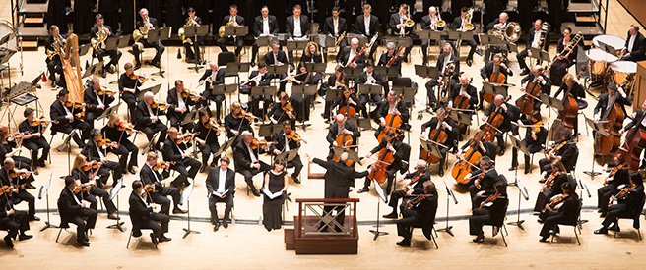
BOOM! POW! Flashing lights! Jarring sounds! Rock music, rap music, pop music, all figures of 21st culture. Their concerts are wild, loud, and flashy, giving attendees a sensory overload throughout their bodies. While we enjoy a jolt of energy and adrenaline from time to time, these raving concerts sometimes need to be contrasted with something calmer and more refined. Standing in stark contrast to the pandemonium of a pop or rock concert lies the centuries old classical orchestra concert. Enjoyed by people since the early 17th century, orchestra concerts have provided a refuge from the often boisterous popular music during different time periods. Popular music does not require many components to sound good – maybe a base beat and some generic upbeat music. Classical music on the other hand requires coordination on the part of the composer, the conductor, and musicians. The music written by a composer must effectively incorporate the disparate instruments contained in the orchestra, from a French horn to a harp. Together, the conductor and musicians must produce the melodies and harmonies in such a way that neither section over powers nor is drowned out. This blend is challenging to achieve for most orchestras. However, an orchestra that does manage to incorporate all the sound elements is the Atlanta Symphony Orchestra. Their performance on March 9th, 2019 gave a sublime rendition of Kodály’s Dances of Galánta, Tchaikovsky’s Symphony No. 4, and Conus’s Violin Concerto. Although the Atlanta Symphony is not world renowned compared with the likes of the New York Philharmonic or the Royal Concertgebouw, their performances are just as good and perhaps, exceed the standards of those other orchestras. Not only is its performance of musical selections excellent, it has a special character that makes it beloved by its audience, a character that even the most prestigious orchestras fail to emulate.
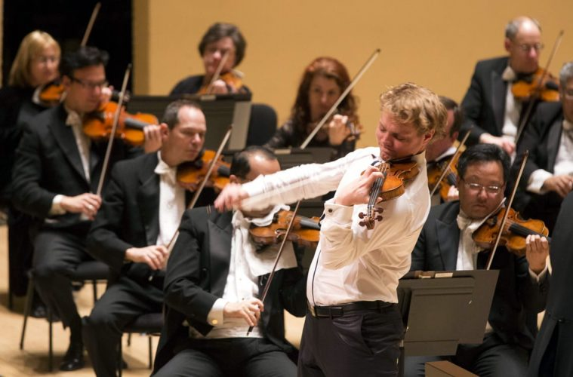
Saturday’s repertoire involved Conductor Robert Spano’s signature ability to string together high impact pieces. The mystic rhythms of Kodály’s Dances of Galánta were played with great contrast in dynamics, almost painting a picture of the dramatic Slovakian folk dance that the song was based on. Next, the Tchaikovsky Symphony No. 4 was played as it was meant to be, powerful and rich during the first movements, and light and airy during the final movements. Written as a song dedicated to Tchaikovsky’s patroness, the Andantino con sostenuto movement portrays the composer’s long winding path to patronage and eventual romance with Nadezhda von Meck. The Pizzicato ostinato scherzo lies in stark contrast to the first two heavy movements. The musicians’ skilled finger work resulted in a rapid pace, giving the audience a sense of the joyful life between the composer and his patroness. Although it descends into minor chords, showcasing periods of doubt and mistrust, the scale soon becomes major once again, showing the lovers’ quick reconciliation. The Allegro con fuoco finale gave the piece a powerful end. The thunderous movement, consisting of complicated rhythms and ear-piercingly high notes demonstrated the typical structure of a symphony finale. The movement was executed with great care and gave the feeling of controlled chaos. The forty-five-minute-long Tchaikovsky piece can be a chore to sit through if not performed well. The Sydney Symphony Orchestra’s performance of this masterpiece did not do justice to his work. The needed dynamics were lacking, and the piece sounded like a haphazard combination of mismatched sounds. However, under Robert Spano’s leadership, the piece was played by the Atlanta Symphony the way in which the composer meant for it to sound. Overall, Kodály and Tchaikovsky were outstanding performances, but they fell just short of exceptional compared to what would come next.

The Conus Violin Concerto is an arduous piece to play for the soloist, often requiring months or even years of practice. However, the Norwegian violinist David Coucheron was able to play the complex solo part with ease, opening the piece like the beginning of a romantic play, and ending the piece with a careful outro like the end of an epic. The piece, though extraordinary, was not actually what made this concert splendid. Rather, it was what happened during the concert that both surprised and comforted the audience. As David Coucheron performed the intense second movement of the concerto, an immense amount of position shifting was required of him to produce the desired notes. All this shifting, however, can cause stress on a string instrument like the violin. And, soon enough, the D string on Coucheron’s Stradivarius violin snapped. His response to the sudden impediment was surprising, though. Instead of being frustrated like other soloists, he nonchalantly said “whoops” and stopped playing, leading the rest of the orchestra to stop playing as well. Coucheron quickly scampered off the stage in search of a replacement string for his violin. As he did that, another surprising thing happened while the orchestra waited. Instead of doing the professional thing – waiting in silence until the soloist returned – the conductor and even some of the musicians in the orchestra had some fun of their own. The conductor made silly gestures sarcastically showing the “agony” he was in while waiting for the Stradivarius to be restrung. Additionally, members of the orchestra made snarky comments about Coucheron, but all in good jest. This moment shifted the mood of the concert from serious to lighter and more relaxed. While orchestras like the New York Philharmonic may be world renowned for their music, they lack the human aspect of music performance. The Atlanta Symphony’s response gave the audience an informal connection to the musicians and made the environment seem less cold. Sure, plenty of classical music connoisseurs may find the Symphony’s response as immature and unprofessional, but for the average audience member like myself, it greatly improved the experience. Personally, I also felt more connected with the orchestra and I felt more in tune with how they were playing. Instead of feeling like just another audience member, I almost felt like a member of the Atlanta Symphony Orchestra “family”. This added value to the entire performance and helped make it better than any other orchestra performance that I have watched. Those who have not yet experienced an Atlanta Symphony performance should definitely try to watch at least one.
The experience watching the Atlanta Symphony Orchestra is priceless, and for Atlanta residents, there is no closer place to go to hear better music. However, there are people that stand fiercely opposed to the “boring” melodies of classical music played at Atlanta Symphony concerts. If you truly do not enjoy the sound of classical music, an Atlanta Symphony concert may not be for you. But for those who enjoy listening to a variety of classical music, from music dating back hundreds to music made this year, it is in their best interest to watch one of their concerts. Tickets begin at less than $20 and getting a favorable seat closer to the stage will only cost $30-$40 more. A concert is affordable and is a good value for all.
The Atlanta Symphony Orchestra without a doubt performs magnificent renditions of widely known classical pieces. Melodies are carefully played to preserve the composer’s vision, while harmonies are gently played to accompany, but not overpower, the melody. Notes are played appropriately for each piece, whether that be by using quick bouncing motions, or long bows that dig deep into the string. But what really makes the orchestra special is its human character. Incorporating the audience into the performance gives the audience a special connection to the orchestra. That connection aides in improving the overall vibe of the performance and makes it more enjoyable. Anyone who is interested in listening to a stunning performance of classics should make it a point to watch the Atlanta Symphony Orchestra.

Sources
https://www.nytimes.com/2019/01/17/arts/music/review-new-york-philharmonic-jaap-van-zweden.html
https://www.washingtonpost.com/entertainment/music/even-a-great-orchestra-needs-a-great-conductor-concertgebouw-pales-at-kennedy-center/2019/02/14/acbb52f0-3084-11e9-813a-0ab2f17e305b_story.html?utm_term=.707653043db7
https://www.atlantasymphony.org/About/Mission-And-History
https://www.atlantasymphony.org/ConcertsAndTickets/Calendar.aspx
https://www.bbc.com/news/entertainment-arts-13856203
https://www.brevardmusic.org/institute/faculty/143/

