Song Response for British Rock Seminar
Dr. Gingrich
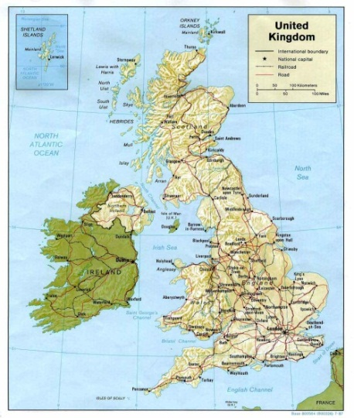
You are to select a song from a British artist. This doesn’t have to be from the Beatles or from the time period of the 60’s. For the song you are to do the following:
- Have access to a recording of the song.
- Investigate the origins of the song-what is it about.
- Discuss why you are interested in it.
- Prepare either an oral or visual interpretation of the song.
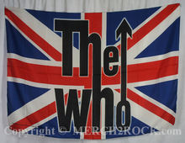
- Be prepared to discuss why you think this song is important? Is it a song that people appreciate as much now as they would have when the song was first produced?
Here is a list of webpages where you can find songs
Best British Rock Artists http://www.digitaldreamdoor.com/pages/best_artists-int-eng.html
50 Best British Artists of All Time
http://www.pastemagazine.com/blogs/lists/2011/04/pastes-50-favorite-british-artists-of-all-time.html?p=5
NME Top 100 British Rock Songs
http://powerlinead.wordpress.com/2009/05/30/xfm-london-names-its-top-100-best-british-songs-of-all-time/
Top Ten British Rock Songs
http://absoluteclassicrock.co.uk/lists/top-10-great-british-rock-songs/

