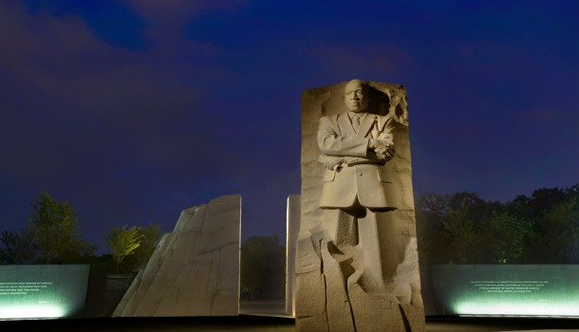
National Museum Activity
Read Landrieu’s speech. What are the strengths and weaknesses of his argument?
Mitch Landrieu Speech on Confederate Monuments in New Orleans

You are to write a proposal for a memorial, museum, or monument. The proposal should include the following.
- The topic/issue
- Location
- Purpose/What you hope a person attending your museum would learn
- Layout/Design
- Target Audience
- List of five artifacts which you would include in the museum
