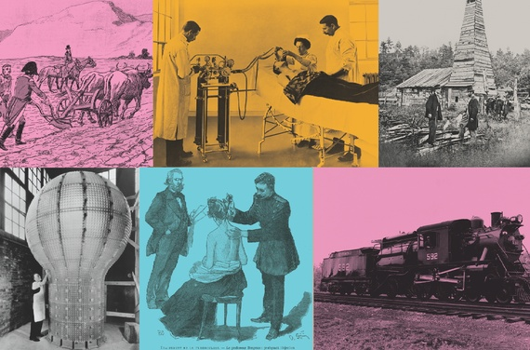
Inventions Activity
For Creativity Class

- View Ted Talk
- http://www.ted.com/talks/saul_griffith_on_everyday_inventions

What do you agree or disagree with in the Ted Talk?
- Read section from How to Think Like Leonardo Da Vinci p. 221-226
What makes a great discovery?
- Look at the following pages on discoveries/inventions-what do you think is the most important inventions we use today? Why is it so significant? How has it changed our lives?
http://www.nbcnews.com/id/38870091/ns/technology_and_science-innovation/t/greatest-accidental-inventions-all-time/#.VRVixvzF-Sp

http://science.howstuffworks.com/innovation/scientific-experiments/5-scientific-breakthroughs-we-couldnt-live-without.htm#page=1

http://www.theatlantic.com/magazine/archive/2013/11/innovations-list/309536/

http://time.com/3594971/the-25-best-inventions-of-2014/

- Consider a current problem that we have today.
- Describe the problem.
- What are possible solutions to the problem?
- Think of and sketch out a potential invention that might solve that problem.
- What resources and abilities would have to go into the creation and exploration of a solution to that problem.

