Fair Pay Isn’t Always Equal Pay
By CHRISTINA HOFF SOMMERSSEPT. 21, 2010
Continue reading the main story Share This Page
- Share
- Tweet
- Email
- More
- Save
Photo
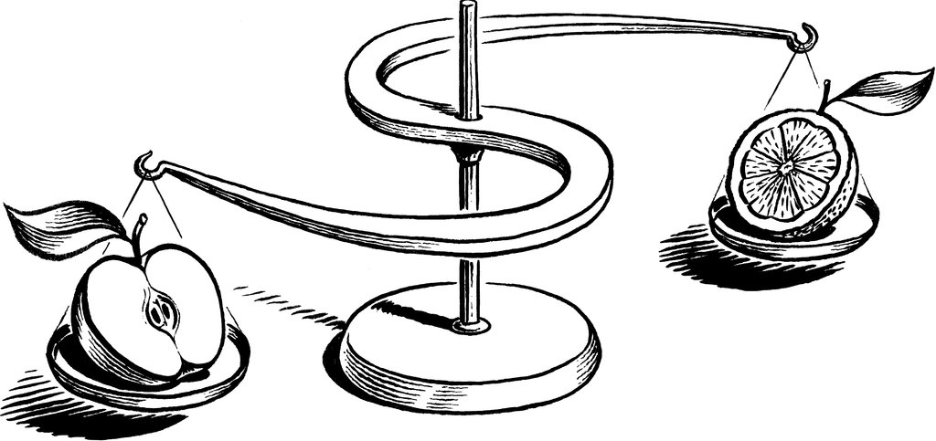
Credit Christophe Vorlet
Washington
AMONG the top items left on the Senate’s to-do list before the November elections is a “paycheck fairness” bill, which would make it easier for women to file class-action, punitive-damages suits against employers they accuse of sex-based pay discrimination.
The bill’s passage is hardly certain, but it has received strong support from women’s rights groups, professional organizations and even President Obama, who has called it “a common-sense bill.”
But the bill isn’t as commonsensical as it might seem. It overlooks mountains of research showing that discrimination plays little role in pay disparities between men and women, and it threatens to impose onerous requirements on employers to correct gaps over which they have little control.
The bill is based on the premise that the 1963 Equal Pay Act, which bans sex discrimination in the workplace, has failed; for proof, proponents point out that for every dollar men earn, women earn just 77 cents.
But that wage gap isn’t necessarily the result of discrimination. On the contrary, there are lots of other reasons men might earn more than women, including differences in education, experience and job tenure.
Continue reading the main story
When these factors are taken into account the gap narrows considerably — in some studies, to the point of vanishing. A recent survey found that young, childless, single urban women earn 8 percent more than their male counterparts, mostly because more of them earn college degrees.
Moreover, a 2009 analysis of wage-gap studies commissioned by the Labor Department evaluated more than 50 peer-reviewed papers and concluded that the aggregate wage gap “may be almost entirely the result of the individual choices being made by both male and female workers.”

Newsletter Sign Up
Continue reading the main story

Opinion Today
Every weekday, get thought-provoking commentary from Op-Ed columnists, The Times editorial board and contributing writers from around the world.

Sign Up
You will receive emails containing news content, updates and promotions from The New York Times. You may opt-out at any time.

- See Sample
- Manage Email Preferences
- Privacy Policy
- Opt out or contact us anytime
In addition to differences in education and training, the review found that women are more likely than men to leave the workforce to take care of children or older parents. They also tend to value family-friendly workplace policies more than men, and will often accept lower salaries in exchange for more benefits. In fact, there were so many differences in pay-related choices that the researchers were unable to specify a residual effect due to discrimination.
Some of the bill’s supporters admit that the pay gap is largely explained by women’s choices, but they argue that those choices are skewed by sexist stereotypes and social pressures. Those are interesting and important points, worthy of continued public debate.
The problem is that while the debate proceeds, the bill assumes the answer: it would hold employers liable for the “lingering effects of past discrimination” — “pay disparities” that have been “spread and perpetuated through commerce.” Under the bill, it’s not enough for an employer to guard against intentional discrimination; it also has to police potentially discriminatory assumptions behind market-driven wage disparities that have nothing to do with sexism.
Universities, for example, typically pay professors in their business schools more than they pay those in the school of social work, citing market forces as the justification. But according to the gender theory that informs this bill, sexist attitudes led society to place a higher value on male-centered fields like business than on female-centered fields like social work.
The bill’s language regarding these “lingering effects” is vague, but that’s the problem: it could prove a legal nightmare for even the best-intentioned employers. The theory will be elaborated in feminist expert testimony when cases go to trial, and it’s not hard to imagine a media firestorm developing from it. Faced with multimillion-dollar lawsuits and the attendant publicity, many innocent employers would choose to settle.
The Paycheck Fairness bill would set women against men, empower trial lawyers and activists, perpetuate falsehoods about the status of women in the workplace and create havoc in a precarious job market. It is 1970s-style gender-war feminism for a society that should be celebrating its success in substantially, if not yet completely, overcoming sex-based workplace discrimination.

Show Them the Money
The United States women’s national soccer team has earned a parade. The players also earned a payday at least equal to their male counterparts’.
By The Editorial Board
The editorial board represents the opinions of the board, its editor and the publisher. It is separate from the newsroom and the Op-Ed section.
- July 8, 2019

  - 454
The United States women’s team members celebrating their World Cup victory.CreditAlex Grimm/Getty Images
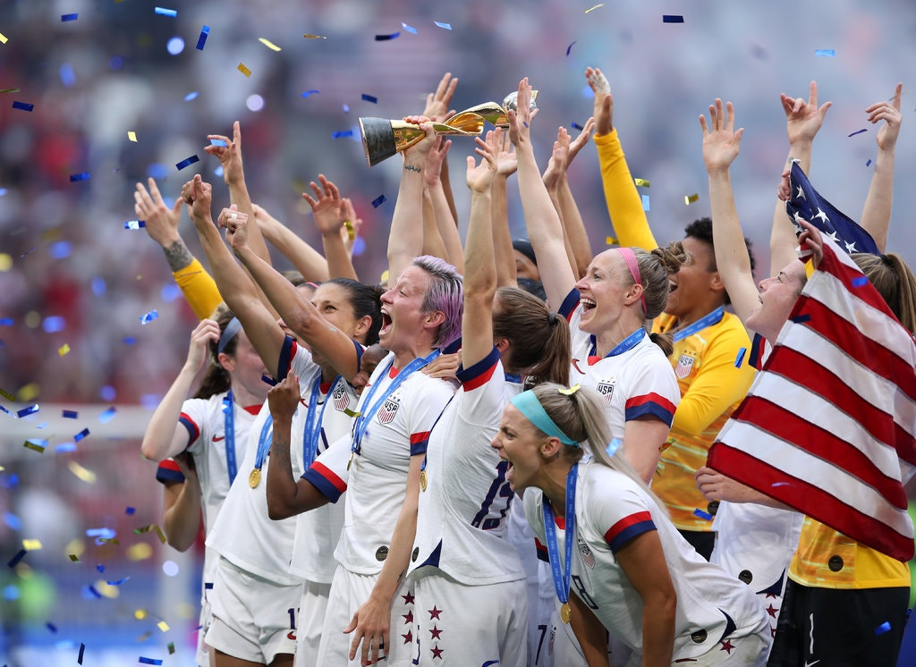
Image
The United States women’s team members celebrating their World Cup victory.CreditCreditAlex Grimm/Getty Images
It is difficult to understand the argument that the United States women’s national soccer team should get paid just as much as the men’s national soccer team.
The women are much more successful. They should earn more.
On Sunday, the 23 women selected to represent the United States at the 2019 World Cup triumphed over the Netherlands to complete a dominating run to victory. It is the second straight time the United States has won the quadrennial tournament.
During the celebrations, fans chanted “equal pay,” highlighting the fact that the United States Soccer Federation, which employs the members of the men’s and women’s national teams, has long paid larger sums to the men. Megan Rapinoe, honored as the World Cup’s top scorer and best player, used her moment in the spotlight to call on United States Soccer to “set things right for the future” by giving the women’s team a raise.
Ms. Rapinoe and her teammates have also gone to court, suing the federation in March for gender discrimination. The allegations extend beyond pay. The suit says United States Soccer also invests less in the team’s practice facilities, travel arrangements and medical care.
It is an embarrassment that United States Soccer has failed to address this injustice, allowing the joy of Sunday’s celebrations to be tainted by the reality of unfair treatment.
Pay comparisons are complicated because the men’s and women’s teams have separately negotiated contracts. Members of the women’s team are paid by the federation to play in the National Women’s Soccer League, on top of which they receive payments for playing for the national team. The men just get national team payments.
Under the current contract for the women’s team, which took effect in April 2017, the women and the men would earn the same amount if both national teams played 20 games — and lost all 20 games. With each victory, however, the men’s team would enjoy a larger advantage.
The women can earn more in a given year, as they are likely to do this year. But that is only because they achieved so much. For comparable success, the women get less.
Much of the debate about the pay gap has focused on revenue. Officials have argued that the men’s team should simply be regarded as a more successful business.

And the men’s national team wants to help. In 2017, Norway agreed to equalize pay for its men’s and women’s national soccer teams. To make the deal possible, the men’s team agreed to share its sponsorship revenues. Admirably, it agreed to earn less as a matter of principle. The union representing the American men’s national team has endorsed this concept.
Pay gaps are a persistent problem in American society. The case of the national soccer teams is merely an unusually clear and public example of the issue. United States Soccer and its 28 female players suing for gender discrimination have agreed to enter mediation in the hopes of resolving the players’ lawsuit. The federation now has the opportunity to create its own clear and public example — by finally doing the right thing.

And the men’s national team wants to help. In 2017, Norway agreed to equalize pay for its men’s and women’s national soccer teams. To make the deal possible, the men’s team agreed to share its sponsorship revenues. Admirably, it agreed to earn less as a matter of principle. The union representing the American men’s national team has endorsed this concept.
Pay gaps are a persistent problem in American society. The case of the national soccer teams is merely an unusually clear and public example of the issue. United States Soccer and its 28 female players suing for gender discrimination have agreed to enter mediation in the hopes of resolving the players’ lawsuit. The federation now has the opportunity to create its own clear and public example — by finally doing the right thing.

