Death Penalty Simulation in connection to In Cold Blood
100 points formative
AP Language and Composition
Dr. Gingrich, SP 2016

Putting men to death in cold blood by human law seems to me a most pernicious and brutalizing practice.» Horace Greeley, 19th Century American educator

May the bad not kill the good,
Nor the good kill the bad
I am a poet, without any bias,
I say without doubt or hesitation
There are no good assassins.»

Pablo Neruda, 20th Century Chilean Poet

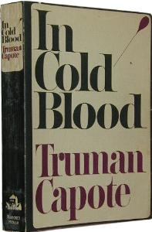
General Guidelines:
For your simulation you are first to read the articles, I am giving you links to a web pages on the issue. Each member will then serve one of the five functions (for groups of six two of the group members may do one of the parts).
Opening:
The death penalty has a long history in the United States as does the prison system. This has been debated within our representative system. Many states have abolished the death penalty. Arguments include the cost, racial and gender bias in those sentenced to the death penalty, accuracies of trials, morality, methods of execution, and constitutionality. Currently, 17 states, beginning with Michigan in 1846 and the District of Columbia have outlawed it while 33 states including Georgia along with the U.S. Military uphold the death penalty. According to Amnesty International, in 2011 the United States ranked 5th in the number of executions with 43, behind Iraq (68), Saudi Arabia (83), Iran (360), and China (no official report but estimates over a thousand, perhaps over four thousand). Based on the position of the individual you are to prepare an argument, using the sources below as support, as to whether or not you support the death penalty in the state of Georgia.
1. Create some background identity for the generic individual you are given.
2. List what factors are most important in considering the death penalty (at least three).
3. Give an opening argument.
4. Respond to the positions of the other groups via questions or responses
5. Present a closing argument which summarizes your position, responds to questions or arguments of other groups.
You must refer to the book In Cold Blood at least three times during your presentation You must cite at least three other sources from below or you may find your own sources and cite those.

Post written responses to 1-3 should be posted to google classroom prior to the debate.
This is the order and time frame for the debate portion. We will begin Monday and finish Tuesday (check that your group members will be here for the days they are to present).
1. Present a description of the biography and experiences of the character ( one paragraph)
2. List the three most important factors and explain why they are the most important (2 minutes) post factors and reasons to google classroom
3. Present an opening argument for your position (3 minutes) post response to google classroom
4. Provide responses or question to the other groups’ openings ( 3 minutes)
5. Present your closing argument (3 minutes)
Each member should familiarize themselves carefully with the readings looking at key aspects. They should be prepared to respond from the perspective of their group’s figure to the situation.

Different Roles for groups
Group A Pro: The parent of a child who was killed
Group B Con: A criminal defense attorney who has defended individuals on death row whose convictions were overturned
Group C Pro: A homicide detective who has solved over fifty homicides in his/her career
Group D Con: a religious cleric who has given last rites to several death row inmates
Group E Pro: A senator from a state that has the death penalty
Group F Con: Human Rights Activist for Amnesty International
Readings for Debate Simulation
Document A: FBI Crime Statistics
http://www.fbi.gov/about-us/cjis/ucr/crime-in-the-u.s/2013/crime-in-the-u.s.-2013/tables/1tabledatadecoverviewpdf/table_1_crime_in_the_united_states_by_volume_and_rate_per_100000_inhabitants_1994-2013.xls

Document B: Gallup Poll

http://www.gallup.com/poll/1606/death-penalty.aspx

Document C: A Short History of Georgia’s Death Penalty from Creative Loafing
http://clatl.com/atlanta/a-short-history-of-georgias-death-penalty/Content?oid=10512956
Document D: “The Humane Death Penalty Charade” from the New York Times
http://www.nytimes.com/2015/01/27/opinion/the-humane-death-penalty-charade.html?_r=1
Document E: The Slow Demise of the Death Penalty from the New York Times
http://www.nytimes.com/2013/12/30/opinion/the-slow-demise-of-capital-punishment.html
Document F: Worst of the Worst Deserve Death Penalty from the Baltimore Sun
http://articles.baltimoresun.com/2013-01-17/news/bs-ed-death-penalty-pro-20130117_1_death-penalty-ultimate-punishment-ultimate-sanction
Document G: Death Penalty deters Crime limit Suffering Oakland Press
http://www.theoaklandpress.com/general-news/20130423/death-penalty-deters-criminals-limits-suffering-guest-opinion
Document H: Put to Death for Being Black from Time Magazine
http://ideas.time.com/2012/05/03/put-to-death-for-being-black-new-hope-against-judicial-system-bias/

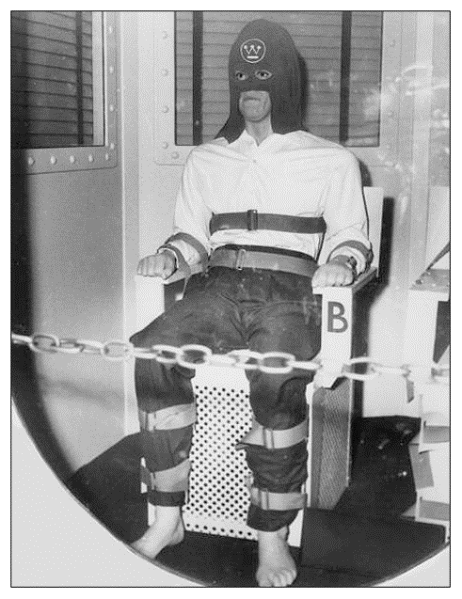

Rubric for Simulation
Team Members Names:
Simulation Topic:

Grade
Category | Inadequate 65-74 | Adequate 75-84 | Effective 85-90 | Exemplary 91-100
Stays in Character  Biography posted to google classroom  (10 points) | Little Knowledge of Character | Clear Knowledge of Character | Thoughtful Representation of Character | Insightful and fully developed representation of character
Knowledge of the Readings/Clarity of  Most important Issues  (factors posted to google classroom) 20 points | Little evidence of readings | Shows knowledge of readings and key ideas | Effectively supports ideas through examples from readings | Displays thorough knowledge of readings by synthesizing information from multiple source
Initial Arguments  (opening posted to google classroom) 25 points | Unclear arguments | Clear and logical arguments | Thoughtful and well supported arguments | Insightful and persuasive arguments
Response to Other Teams/ Questions  20 points | Little knowledge of oppositional arguments and ability to respond  Unclear questions | Careful knowledge and ability to respond; signs of active listening  Adequate Questions | Responds to and critiques/elaborates on other teams’ positions  Clear and well thought out questions | Sophisticated analysis, critique, and elaboration upon the arguments of other teams  Superior questions show close analysis of other group’s presentation and sophisticated knowledge of key and issues
Final Response  25 points | Unclear arguments | Clear and Logical  arguments | Thoughtful and well supported arguments | Insightful and persuasive arguments
Total score

