In the Heart of the Sea
By: Nathaniel Philbrick
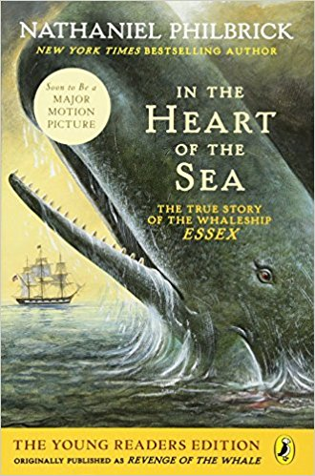
Subject: Travel/Adventure

On November 20, 1820, the whaleship Essex was rammed and sunk by an angry whale. Within minutes, the twenty-one-man crew, including the fourteen-year-old cabin boy Thomas Nickerson, found themselves stranded in three leaky boats in the middle of the Pacific Ocean with barely any supplies and little hope. Three months later, two of the boats were rescued 4,500 miles away, off the coast of South America. Of the twenty-one castaways, only eight survived, including young Thomas. Based on his New York Times best-seller In the Heart of the Sea, Nathaniel Philbrick recreates the amazing events of the ill-fated Essex through the sailors own first-hand accounts, photos, maps, and artwork, and tells the tale of one of the great true-life adventure stories.

"A compelling saga of desperation and survival." —School Library Journal

Eyes Wide Open
By:Paul Fleischman
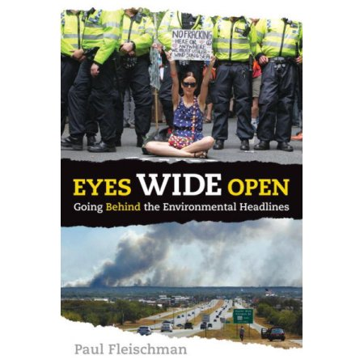
Subject: Nature and Environment

We're living in an Ah-Ha moment. Take 250 years of human ingenuity. Add abundant fossil fuels. The result: a population and lifestyle never before seen. The downsides weren't visible for centuries, but now they are. Suddenly everything needs rethinking – suburbs, cars, fast food, cheap prices. It's a changed world. This book explains it. Not with isolated facts, but the principles driving attitudes and events, from vested interests to denial to big-country syndrome. Because money is as important as molecules in the environment, science is joined with politics, history, and psychology to provide the briefing needed to comprehend the 21st century.

“ It's one of the most challenging, provocative, and cogently written books about the world's current and coming environmental crises.”- Edward Sullivan

Debunk It!
By: John Grant
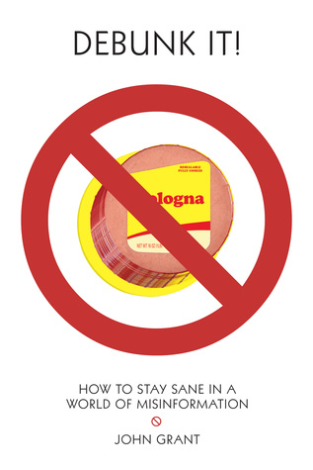
Subject: Thoughts/Ideas

We live in an era of misinformation, much of it spread by authority figures, including politicians, religious leaders, broadcasters, high-traffic bloggers, and, of course, websites. With so much bullshit coming from so many sources, how can anyone be expected to discover the truth? Well, if you are tired of hearing blowhards spouting off about climate change, history, evolution, medicine, and more, you'll find this book full of invaluable facts that will startle and amuse you.

“Everyone, young and old, needs to read this book and keep a copy handy for reference.”- goodreads

The Watch that Ends the Night
By: Allan Wolf
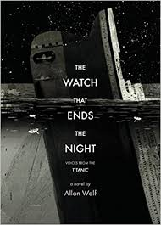
Subject: Thoughts/Ideas

Millionaire John Jacob Astor hopes to bring home his pregnant teen bride with a minimum of media scandal. A beautiful Lebanese refugee, on her way to family in Florida, discovers the first stirrings of love. And an ancient iceberg glides south, anticipating its fateful encounter. The voices in this remarkable re-creation of the Titanic disaster span classes and stations, from Margaret ("the unsinkable Molly") Brown to the captain who went down with his ship; from the lookout and wireless men to a young boy in search of dragons and a gambler in search of marks. Slipping in telegraphs, undertaker's reports, and other records, poet Allan Wolf offers a breathtaking, intimate glimpse at the lives behind the tragedy, told with clear-eyed compassion and astounding emotional power.

“A masterpiece. Wolf leaves no emotion unplumbed, no area of research uninvestigated, and his voices are so authentic they hurt. Everyone should read it.”—Booklist

Fast Food Nation
By: Eric Schlosser
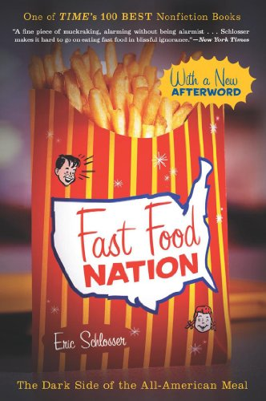
Subject: Food

Eric Schlosser’s exposé reveals how the fast food industry has altered the landscape of America, widened the gap between rich and poor, fueled an epidemic of obesity, and transformed food production throughout the world. The book changed the way millions of people think about what they eat and helped to launch today’s food movement. The book inspires readers to look beneath the surface of our food system, consider its impact on society and, most of all, think for themselves.

"An exemplary blend of polemic and journalism....A tale full of sound, fury, and popping grease."
— Kirkus Reviews

Processing Your Food
By: John Bliss
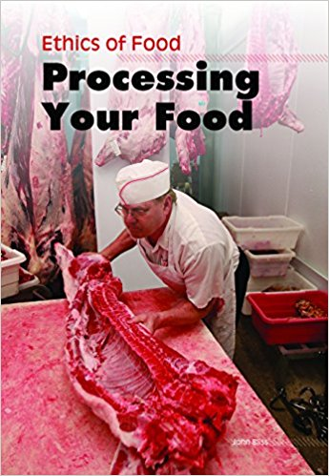
Subject: Food

Where does it go and what is it used for once it has been farmed, raised, or caught? Covers slaughter and processing of meat, food additives and preservatives, GM food, outbreaks from tainted food, etc.

“Focusing on how food gets from farms, factories, and laboratories to our grocery stores then to our tables, this series is an extremely informative look at food and eating lifestyles around the world. Each volume includes ""Health Watch"" in which students” --Library Media Connection

Foodprints
By: Paula Ayer
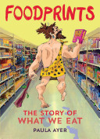
Subject: Food

The everyday choices we make when it comes to food don’t just have an effect on us—they also affect other people and the planet. Today’s teens are more attuned to what they eat and where it comes from, but there’s still more to know. Foodprints enables readers to sort through the numerous messages they hear and read about food while getting the big picture about food production, marketing, and its role in society

“I like this book!”- goodreads

In Defense of Food
By:Michael Pollan
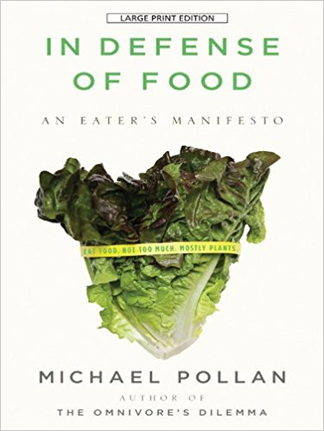
Subject: Food

Humans used to know how to eat well, Pollan argues. But the balanced dietary lessons that were once passed down through generations have been confused, complicated, and distorted by food industry marketers, nutritional scientists, and journalists-all of whom have much to gain from our dietary confusion. As a result, we face today a complex culinary landscape dense with bad advice and foods that are not "real." These "edible food like substances" are often packaged with labels bearing health claims that are typically false or misleading. Indeed, real food is fast disappearing from the marketplace, to be replaced by "nutrients," and plain old eating by an obsession with nutrition that is, paradoxically, ruining our health, not to mention our meals. Michael Pollan's sensible and decidedly counterintuitive advice is: "Don't eat anything that your great-great grandmother would not recognize as food."

“Great book, a must read for anyone who is interested in food, nutrition and culture.” -- Amazon

The Worst Hard Time
By: Timothy Egan
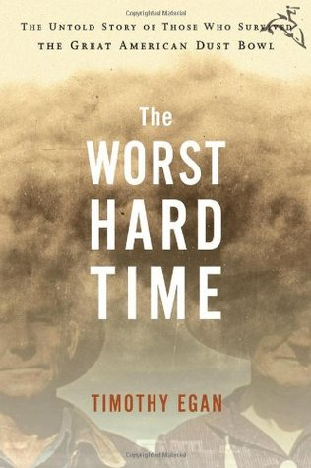
Subject:

The dust storms that terrorized America's High Plains in the darkest years of the Depression were like nothing ever seen before or since, and the stories of the people that held on have never been fully told. Pulitzer Prize–winning New York Times journalist and author Timothy Egan follows a half-dozen families and their communities through the rise and fall of the region, going from sod homes to new framed houses to huddling in basements with the windows sealed by damp sheets in a futile effort to keep the dust out. He follows their desperate attempts to carry on through blinding black blizzards, crop failure, and the deaths of loved ones. Drawing on the voices of those who stayed and survived—those who, now in their eighties and nineties, will soon carry their memories to the grave—Egan tells a story of endurance and heroism against the backdrop of the Great Depression.

"The Worst Hard Time" provides a sobering, gripping account of a disaster whose wounds are still not fully healed today.”--Boston Globe

It’s Not All Black and White
By: St. Stephen's Community House
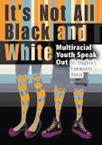
Subject: Race/Religion

Black, white, and everything in between … Through poems, interviews, and short essays, a group of young people tell what it’s like to be biracial, multiracial, or of mixed race. These poignant firsthand accounts reflect the unique and varied voices of the writers, whose backgrounds range from Caribbean, Vietnamese, and Latin American to First Nations, Spanish, and Irish, among others. With devastating honesty, the youth tell what it’s been like to make their way in the world with their roots in many places and in many cultures. Themes include navigating mixed-race relationships, dealing with prejudice and the assumptions people make based on appearances, and working through identity confusion to arrive at a strong and positive sense of self. Readers who share these experiences will find comfort, inspiration, and validation. Those less familiar with the issues will gain important insight and understanding.

“Interesting narrative from personal honest perspectives. Rings true to life. A great concept to draw people into the conversation about the joys and heartaches of being biracial-Amazon

The Nazi Hunters
By:Neal Bascomb
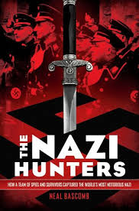
Subject: War

In 1945, at the end of World War II, Adolf Eichmann, the head of operations for the Nazis' Final Solution, walked into the mountains of Germany and vanished from view. Sixteen years later, an elite team of spies captured him at a bus stop in Argentina and smuggled him to Israel, resulting in one of the century's most important trials -- one that cemented the Holocaust in the public imagination.

“Amazing story of the hunt for Eichmann and the serendipitous manner in which he was discovered in Argentina.”-- Amazon

In the Land of the Invisible Women
By:Qanta A. Ahmed
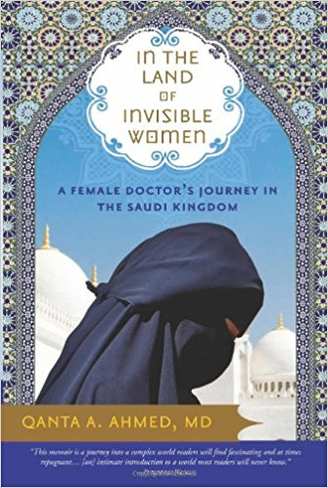
Subject: Race/Religion

Unexpectedly denied a visa to remain in the United States, Qanta Ahmed, a young British Muslim doctor, becomes an outcast in motion. On a whim, she accepts an exciting position in Saudi Arabia. This is not just a new job; this is a chance at adventure in an exotic land she thinks she understands, a place she hopes she will belong. What she discovers is vastly different. The Kingdom is a world apart, a land of unparalleled contrast. She finds rejection and scorn in the places she believed would most embrace her, but also humor, honesty, loyalty and love. And for Qanta, more than anything, it is a land of opportunity. A place where she discovers what it takes for one woman to recreate herself in the land of invisible women.

“This is a fascinating, riveting look at the gender divide in Saudi Arabia.”

When I was Puerto Rican
By: Esmeralda Santiago
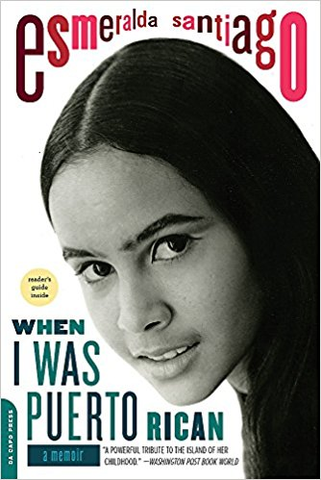
Subject: Race/Religion

Esmeralda Santiago's story begins in rural Puerto Rico, where her childhood was full of both tenderness and domestic strife, tropical sounds and sights as well as poverty. Growing up, she learned the proper way to eat a guava, the sound of tree frogs in the mango groves at night, the taste of the delectable sausage called morcilla, and the formula for ushering a dead baby's soul to heaven. As she enters school we see the clash, both hilarious and fierce, of Puerto Rican and Yankee culture. When her mother, Mami, a force of nature, takes off to New York with her seven, soon to be eleven children, Esmeralda, the oldest, must learn new rules, a new language, and eventually take on a new identity. In this first volume of her much-praised, bestselling trilogy, Santiago brilliantly recreates the idyllic landscape and tumultuous family life of her earliest years and her tremendous journey from the barrio to Brooklyn, from translating for her mother at the welfare office to high honors at Harvard.

"Santiago brilliantly recreates the idyllic landscape and tumultuous family life of her earliest years and her tremendous journey from the barrio to Brooklyn, from translating for her mother at the welfare office to receiving high honors at Harvard. Santiago's story is one of the American dream both realized and deferred." ―Bustle.com

DRiVE
By: Daniel H. Pink
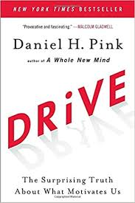
Subject: Thoughts/Ideas

Most people believe that the best way to motivate is with rewards like money--the carrot-and-stick approach. That's a mistake, says Daniel H. Pink in Drive. In this provocative and persuasive new book, he asserts that the secret to high performance and satisfaction--at work, at school, and at home--is the deeply human need to direct our own lives, to learn and create new things, and to do better by ourselves and our world.

“Drive is an intriguing book which unpacks motivation and explores what really motivates people to do what they do.”- Amazon

Sports and Society
By: Scott Witmer
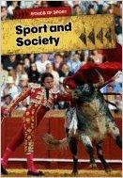
Subject: Sports

Sports and Society examines the role that sporting traditions have played in human society from primitive cultures to the present day. Did sports begin simply for practical reasons such as training soldiers for war, or do humans have a less practical need to play active, physical games? How have different sports migrated around the world, and what effect have new cultures had on these imports? Exciting and varied case studies are used throughout this book to illustrate issues and concepts.

“An intriguing look at the ethics of sports in today's modern world”

Real Justice
By: Bill Swan
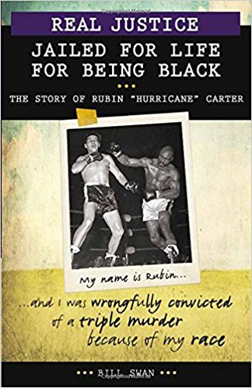
Subject: Race/Religion

Rubin Carter was in and out of prison from the age of twelve. At twenty-four, he became a professional boxer and was turning his life around. But Carter was very vocal about racism in the local police force. In 1966, he and a friend were arrested and convicted of a triple murder. Carter spent nearly twenty years in jail, proclaiming his innocence. Teenaged Lesra Martin heard Carter's story and believed he was innocent. He and a group of lawyers contacted Carter and began working to get him exonerated. In 1985, a judge released Carter, ruling that the conviction had been based on racism.

"An inspiring story, especially for students facing obstacles similar to Carter’s— the speech impediment, the childhood abuse, the racism and all the travesties of justice that follow in its wake. A list of additional resources points those whose interest is piqued to a wealth of extra material."- Amazon

The Reason I Jump
By: Naoki Higashida
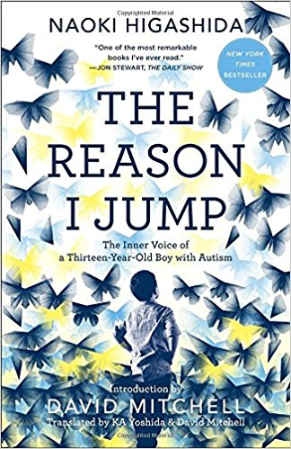
Subject: Thoughts/Ideas

You’ve never read a book like The Reason I Jump. Written by Naoki Higashida, a very smart, very self-aware, and very charming thirteen-year-old boy with autism, it is a one-of-a-kind memoir that demonstrates how an autistic mind thinks, feels, perceives, and responds in ways few of us can imagine. Parents and family members who never thought they could get inside the head of their autistic loved one at last have a way to break through to the curious, subtle, and complex life within.

“Small but profound . . . [Higashida’s] startling, moving insights offer a rare look inside the autistic mind.”—Parade

Between the World and Me
By: Ta-Nehisi Coates
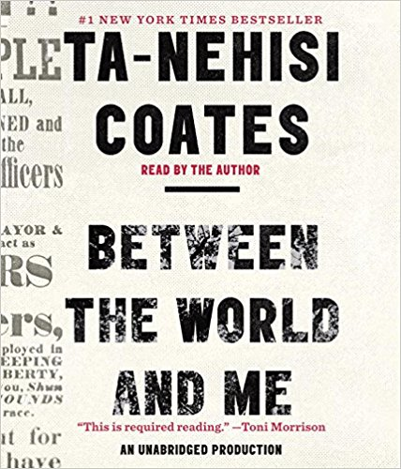
Subject: Race/Religion

In a profound work that pivots from the biggest questions about American history and ideals to the most intimate concerns of a father for his son, Ta-Nehisi Coates offers a powerful new framework for understanding our nation’s history and current crisis. Americans have built an empire on the idea of “race,” a falsehood that damages us all but falls most heavily on the bodies of black women and men—bodies exploited through slavery and segregation, and, today, threatened, locked up, and murdered out of all proportion. What is it like to inhabit a black body and find a way to live within it? And how can we all honestly reckon with this fraught history and free ourselves from its burden?

“Urgent, lyrical, and devastating . . . a new classic of our time.”—Vogue

Start Something that Matters
By: Blake Mycoskie
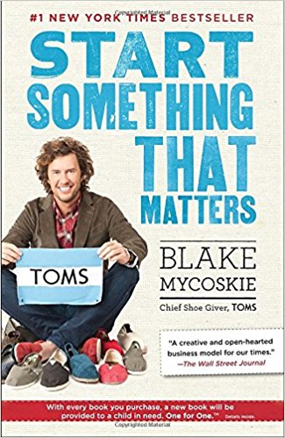
Subject: Thoughts/Ideas

In Start Something That Matters, Blake Mycoskie tells the story of TOMS, one of the fastest-growing shoe companies in the world, and combines it with lessons learned from such other innovative organizations such as Method Products, charity: water, FEED Projects, and TerraCycle. Blake presents the six simple keys for creating or transforming your own life and business, from discovering your core story to being resourceful without resources; from overcoming fear and doubt to incorporating giving into every aspect of your life. No matter what kind of change you’re considering, Start Something That Matters gives you the stories, ideas, and practical tips that can help you get started.

“Phenomenal book. Inspirational and practical at the same time! Great read and it makes you think.”-Amazon

We wish to inform you that tomorrow we will be killed with our families
By: Philip Gourevitch

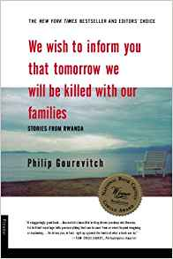
Subject: War

This remarkable debut book chronicles what has happened in Rwanda and neighboring states since 1994, when the Rwandan government called on everyone in the Hutu majority to murder everyone in the Tutsi minority. Though the killing was low-tech--largely by machete--it was carried out at shocking speed: some 800,000 people were exterminated in a hundred days. A Tutsi pastor, in a letter to his church president, a Hutu, used the chilling phrase that gives Philip Gourevitch his title.

“The most important book I have read in many years . . . [Gourevitch] examines [the genocidal war in Rwanda] with humility, anger, grief and a remarkable level of both political and moral intelligence.” ―Susie Linfield, Los Angeles Times

The Big Short
By: Michael Lewis
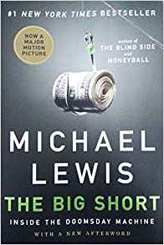
Subject: Thoughts/ Ideas

The real story of the crash began in bizarre feeder markets where the sun doesn't shine and the SEC doesn't dare, or bother, to tread: the bond and real estate derivative markets where geeks invent impenetrable securities to profit from the misery of lower- and middle-class Americans who can't pay their debts. The smart people who understood what was or might be happening were paralyzed by hope and fear; in any case, they weren't talking.

“I read Lewis for the same reasons I watch Tiger Woods. I’ll never play like that. But it’s good to be reminded every now and again what genius looks like.”
- Malcolm Gladwell, New York Times Book Review

A Volcano Beneath the Snow
By: Albert Marrin
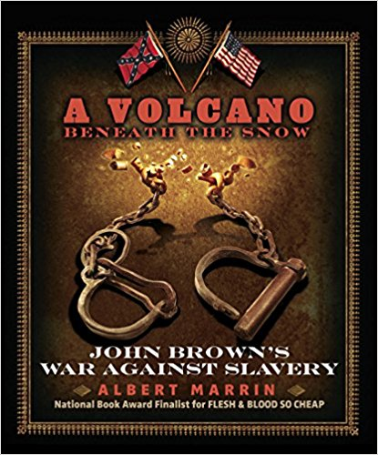
Subject: Race and Culture

John Brown is a man of many legacies, from hero, freedom fighter, and martyr, to liar, fanatic, and "the father of American terrorism." Some have said that it was his seizure of the arsenal at Harper's Ferry that rendered the Civil War inevitable. Deeply religious, Brown believed that God had chosen him to right the wrong of slavery. He was willing to kill and die for something modern Americans unanimously agree was a just cause. And yet he was a religious fanatic and a staunch believer in "righteous violence," an unapologetic committer of domestic terrorism. Marrin brings 19th-century issues into the modern arena with ease and grace in a book that is sure to spark discussion.

This is an excellent book on one of the more turbulent events in our history. John Brown is a polarizing figure and this book gives him some kind of "life" and makes you realize what kind of man he is. - Amazon

Friday Night Lights
By: H. G. Bissinger
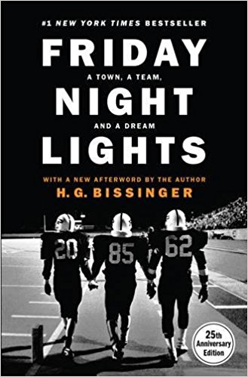
Subject: Sports

Return once again to the timeless account of the Permian Panthers of Odessa--the winningest high-school football team in Texas history. Odessa is not known to be a town big on dreams, but the Panthers help keep the hopes and dreams of this small, dusty town going. Socially and racially divided, its fragile economy follows the treacherous boom-bust path of the oil business. In bad times, the unemployment rate barrels out of control; in good times, its murder rate skyrockets. But every Friday night from September to December, when the Permian High School Panthers play football, this West Texas town becomes a place where dreams can come true. With frankness and compassion, H. G. Bissinger chronicles a season in the life of Odessa and shows how single-minded devotion to the team shapes the community and inspires--and sometimes shatters--the teenagers who wear the Panthers' uniforms. The authors new afterword not only updates the story but also offers a sure-to-be controversial assessment of the state of football today.

"[An] inspiring story about a small town and it's unbelievable football team. Starring unforgettable characters in a setting you'll never want to leave, this is a must-read for true fans."―Bustle.com

League of Denial
By: Mark Fainaru-Wada and Steve Fainaru
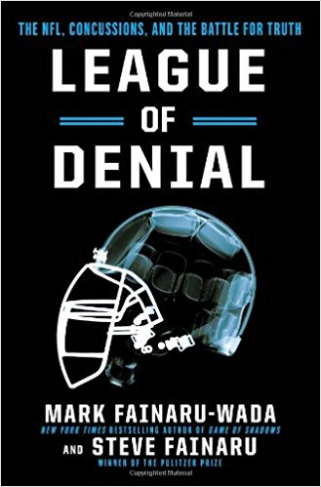
Subject: Sports

“PROFESSIONAL FOOTBALL PLAYERS DO NOT SUSTAIN FREQUENT REPETITIVE BLOWS TO THE BRAIN ON A REGULAR BASIS.”
So concluded the National Football League in a December 2005 scientific paper on concussions in America’s most popular sport. That judgment, implausible even to a casual fan, also contradicted the opinion of a growing cadre of neuroscientists who worked in vain to convince the NFL that it was facing a deadly new scourge: A chronic brain disease that was driving an alarming number of players -- including some of the all-time greats -- to madness.

"It is meticulously researched, artfully structured, engaging and well written... this is an informative, intriguing and sobering book about power and control. I recommend it strongly." - Nate Jackson, The Washington Post

The Good Soldiers
By: David Finkel
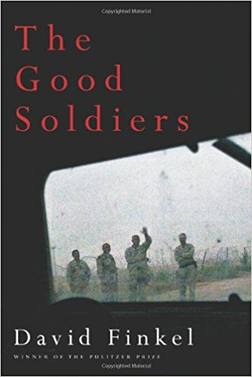
Subject: War

It was the last-chance moment of the war. In January 2007, President George W. Bush announced a new strategy for Iraq. He called it the surge. “Many listening tonight will ask why this effort will succeed when previous operations to secure Baghdad did not. Well, here are the differences,” he told a skeptical nation. Among those listening were the young, optimistic army infantry soldiers of the 2-16, the battalion nicknamed the Rangers. About to head to a vicious area of Baghdad, they decided the difference would be them.

“Lots of hard truths and difficult issues. War has no good conclusion and even fewer positive outcomes.” -Amazon

The Boys in the Boat
By: Daniel James Brown
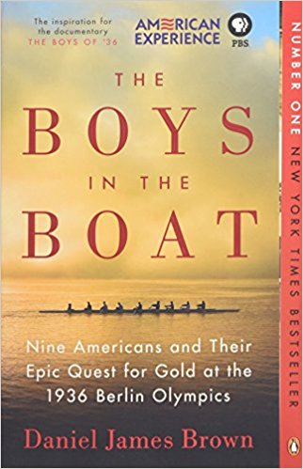
Subject: Sports

For readers of Unbroken, out of the depths of the Depression comes an irresistible story about beating the odds and finding hope in the most desperate of times—the improbable, intimate account of how nine working-class boys from the American West showed the world at the 1936 Olympics in Berlin what true grit really meant.

Daniel James Brown’s The Boys in the Boat is the kind of nonfiction book that reads like a novel. - Amazon

The Final Four
By: Paul Volponi
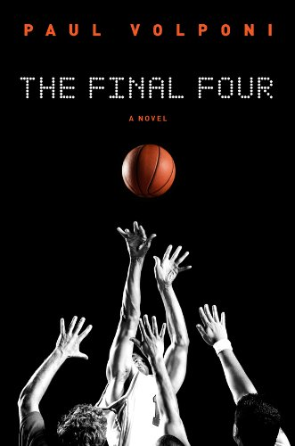
Subject: Sports

March Madness is in full swing, and there are only four teams let in the NCAA basketball championship. The heavily favored Michigan Spartans and the underdog Troy Trojans meet in the first game in the semi finals, and it's there that the fates of Malcolm, Roko, Crispin, and M.J. intertwine. As the last moments tick down on the game clock, you'll learn how each player went from being a kid who loves to shoot hoops to a powerful force in one of the most important games of the year. Which team will leave the Superdome victorious? In the end it will come down to who has the most skill, the most drive, and the most heart.

"Volponi adroitly renders authentic and inspired basketball action." —The New York Times Book Review

War Brothers
By: Sharon E. McKay
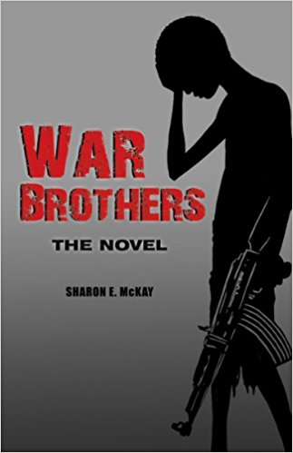
Subject: War

The unforgettable novel about one child soldier’s struggle with friendship, courage, and resilience. Jacob is a 14-year-old Ugandan who is sent away to a boys’ school. Once there, he assures his friend Tony that they need not be afraid—they will be safe. But not long after, in the shadow of the night, the boys are abducted. Marched into the jungle, they are brought to an encampment of the feared rebel soldiers. Told that they must kill or be killed, the boys are thrust into a terrifying struggle to endure and survive. In time, the boys escape. Hunted by the rebels, stalked by a lion, and even pursued by river crocs, they miraculously succeed in reaching safety; however, it is no longer enough. Jacob’s adventures force him to confront evil, victimization, and the dark side of human nature, but also teach him about loyalty, friendship, and the true meaning of family. War Brothers was originally published in 2008, in Canada. Annick is now making the award-winning novel available to American readers, with powerful, striking cover art by Daniel Lafrance. This edition is not available in Canada. The novel was recently adapted into a critically acclaimed graphic novel.

“Shocking, heartbreaking, powerful, unforgettable.”- Amazon

Parkland Dave Cullen
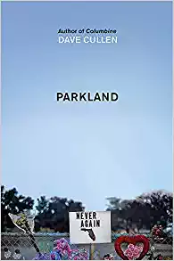

Something changed with Parkland. When Nicolas Cruz shot seventeen students and teachers at Marjory Stoneman Douglas High School in Florida on 14th February 2018, the story was tragic and familiar. Yet the eighth school shooting that year made history for another reason.
Days afterwards, young, traumatised survivors were galvanising their grief and outrage into action. Social media blazed with calls for gun control, and America listened. In just a few weeks, they organised national school walkouts, TV debates with senators and a march on Washington.... He will take the reader inside the school in the days before the shooting, where students anticipate exam results and rehearse the school play. He will recreate the six minutes it took for their world to shatter. And he'll follow, with exclusive access, the self-described 'misfits' who became the core of the campaign movement.

“I give this book my highest and most wholehearted recommendation — and, whether you agree or not with the cause, I think we can all agree that the world would be a better place if we... exhibited a fraction of the courage and determinedness of these kids when it comes to things that matter to us. And for those who do support the cause, I think you’ll probably feel even more committed to it and for sure committed to supporting these kids however possible.” - Amazon

New Jim Crow
By Michelle Alexnder
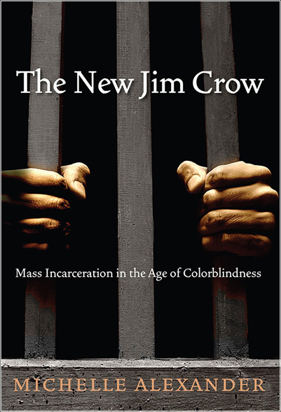

As the United States celebrates its “triumph over race” with the election of Barack Obama, the majority of black men in major urban areas are under correctional control or saddled with criminal records for life. Jim Crow laws were wiped off the books decades ago, but today an extraordinary percentage of the African American community is warehoused in prisons or trapped in a parallel social universe, denied basic civil and human rights—including the right to vote; the right to serve on juries; and the right to be free of legal discrimination in employment, housing, access to education and public benefits. Today, it is no longer socially permissible to use race explicitly as a justification for discrimination, exclusion, and social contempt. Yet as civil-rights-lawyer-turned-legal-scholar Michelle Alexander demonstrates, it is perfectly legal to discriminate against convicted criminals in nearly all the ways in which it was once legal to discriminate against African Americans. Once labeled a felon, even for a minor drug crime, the old forms of discrimination are suddenly legal again. In her words, “we have not ended racial caste in America; we have merely redesigned it.

“"[C]arefully researched, deeply engaging, and thoroughly readable."
— Publishers Weekly

Columbine
By David Cullen
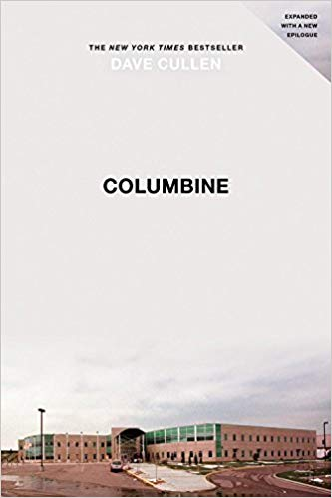
What really happened April 20, 1999? The horror of Columbine left an indelible stamp on the American psyche, but most of what we "know" is wrong. It wasn't about jocks, goths, or the Trench Coat Mafia. Dave Cullen was one of the first reporters on scene, and spent ten years on this book -- widely recognized as the definitive account. With a keen investigative eye and psychological acumen, Cullen draws on mountains of evidence, insights from the world's leading forensic psychologists, and the killers' own words and drawings -- several reproduced in a new appendix for the paperback.
In this New York Times bestselling work, Cullen paints raw portraits of two polar opposite killers, who stand in stark contrast against the flashes of resilience and redemption among the survivors of the Columbine massacre.

"A chilling page-turner, a striking accomplishment given that Cullen's likely readers almost certainly know how the tragic story ends...I knew Cullen was a dogged reporter and a terrific writer, but even I was blown away by the pacing and story-telling he mastered in Columbine, a disturbing, inspiring work of art."―Salon

In Cold Blood
By Truman Capote

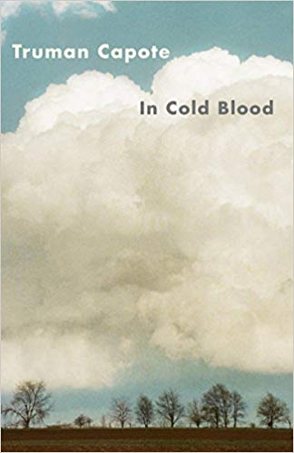

On November 15, 1959, in the small town of Holcomb, Kansas, four members of the Clutter family were savagely murdered by blasts from a shotgun held a few inches from their faces. There was no apparent motive for the crime, and there were almost no clues.
As Truman Capote reconstructs the murder and the investigation that led to the capture, trial, and execution of the killers, he generates both mesmerizing suspense and astonishing empathy. In Cold Blood is a work that transcends its moment, yielding poignant insights into the nature of American violence.

“It's a classic of the true crime genre, the one against which all others are judged, and the most disturbing, compelling, book I've ever read. The big reveal in In Cold Blood isn't who killed the Clutter family — you know who murdered Herb, Bonnie and their two teenage kids. The challenge for Capote, and the reason it's the perfect book to read now, is that he managed to make the story gripping even though you know the end.” - npr

Devil in the White City
By Erik Larson
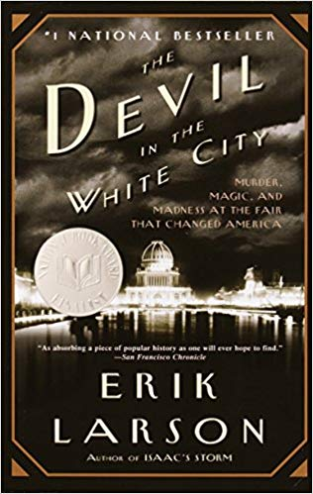

Erik Larson—author of #1 bestseller In the Garden of Beasts—intertwines the true tale of the 1893 World's Fair and the cunning serial killer who used the fair to lure his victims to their death. Combining meticulous research with nail-biting storytelling, Erik Larson has crafted a narrative with all the wonder of newly discovered history and the thrills of the best fiction.

"So good, you find yourself asking how you could not know this already." — Esquire

Dreamland: the True Tale of America’s Opioid Epidemic
By Sam Quinones

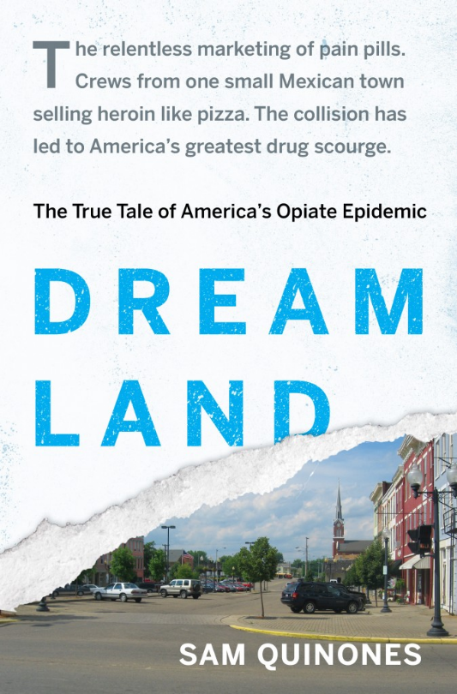

n 1929, in the blue-collar city of Portsmouth, Ohio, a company built a swimming pool the size of a football field; named Dreamland, it became the vital center of the community. Now, addiction has devastated Portsmouth, as it has hundreds of small rural towns and suburbs across America—addiction like no other the country has ever faced. How that happened is the riveting story of Dreamland.

“This book rocked my world. Shocking to me in many ways. The combination of misinformation, desire for monetary success, and ingenuity in "beating the system" created such havoc in this country. I won't be be able to forget this book.” - Amazon

Moneyball by Michael Lewis
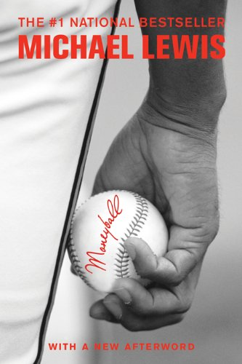

Subject: Sports

Lewis (Liar's Poker; The New New Thing) examines how in 2002 the Oakland Athletics achieved a spectacular winning record while having the smallest player payroll of any major league baseball team. Given the heavily publicized salaries of players for teams like the Boston Red Sox or New York Yankees, baseball insiders and fans assume that the biggest talents deserve and get the biggest salaries. However, argues Lewis, little-known numbers and statistics matter more.

"...the best and most engrossing sports book I've read for years. If you know anything about baseball, you will enjoy it four times as much as I did, which means you might explode." Nick Hornby "...his grandest tour de force yet." Tom Wolfe "...the most riveting sports book of the year." The Observer "[Lewis has] a gift for pithy observation and a wonderful turn of phrase..." The Times Literary Supplement

War by Sebastian Junger

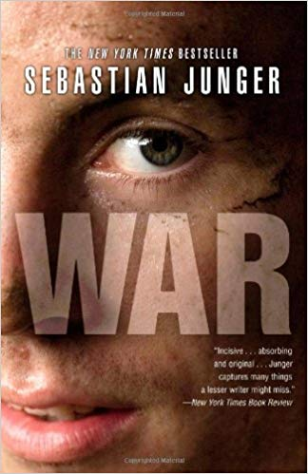

Subject: War
In WAR, Sebastian Junger (The Perfect Storm) turns his brilliant and empathetic eye to the reality of combat--the fear, the honor, and the trust among men in an extreme situation whose survival depends on their absolute commitment to one another. His on-the-ground account follows a single platoon through a 15-month tour of duty in the most dangerous outpost in Afghanistan's Korengal Valley. Through the experiences of these young men at war, he shows what it means to fight, to serve, and to face down mortal danger on a daily basis.

"Absorbing and original . . . Junger is aiming for more than just a boots-on-the-ground narrative of the travails of fighting men . . . . WAR strives to offer not just a picture of American fighting men but a discourse on the nature of war itself. This is no small ambition . . . He writes some beautiful sentences about this ugly world."―Dexter Filkins, New York Times Book Review

Unbroken by Laura Hillenbrand

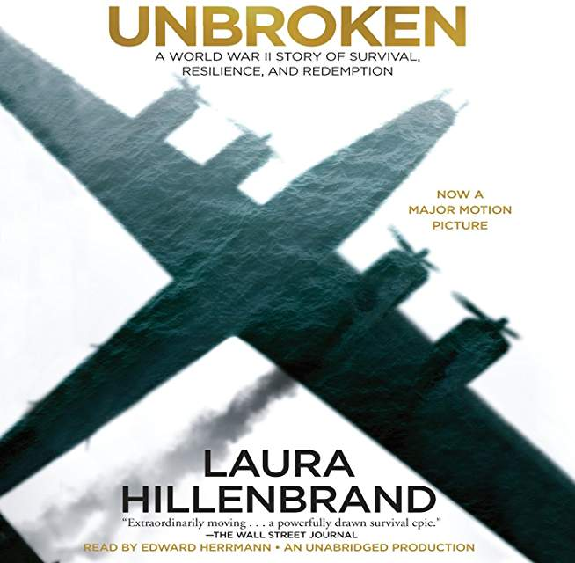

Subject: War
On a May afternoon in 1943, an Army Air Forces bomber crashed into the Pacific Ocean and disappeared, leaving only a spray of debris and a slick of oil, gasoline, and blood. Then, on the ocean surface, a face appeared. It was that of a young lieutenant, the plane's bombardier, who was struggling to a life raft and pulling himself aboard. So began one of the most extraordinary odysseys of the Second World War.
The lieutenant’s name was Louis Zamperini. In boyhood, he'd been a cunning and incorrigible delinquent, breaking into houses, brawling, and fleeing his home to ride the rails. As a teenager, he had channeled his defiance into running, discovering a prodigious talent that had carried him to the Berlin Olympics and within sight of the four-minute mile. But when war had come, the athlete had become an airman, embarking on a journey that led to his doomed flight, a tiny raft, and a drift into the unknown.

Black Hawk Down by Mark Bowden
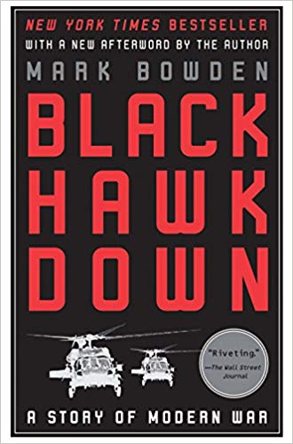
Subject: War
Already a classic of war reporting and now reissued as a Grove Press paperback, Black Hawk Down is Mark Bowden’s brilliant account of the longest sustained firefight involving American troops since the Vietnam War. On October 3, 1993, about a hundred elite U.S. soldiers were dropped by helicopter into the teeming market in the heart of Mogadishu, Somalia.

Concussion by Jeanne Laskas
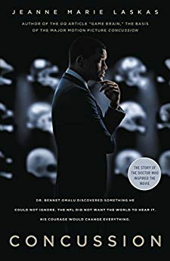

Subject: Sports
NEW YORK TIMES BESTSELLER • The riveting, unlikely story of Dr. Bennet Omalu, the pathologist who first identified CTE in professional football players, a discovery that challenges the existence of America’s favorite sport and puts Omalu in the crosshairs of football’s most powerful corporation: the NFL

“The story of Dr. Bennet Omalu’s battle against the NFL is classic David and Goliath stuff, and Jeanne Marie Laskas—one of my favorite writers on earth—makes it as exciting as any great courtroom or gridiron drama. A riveting, powerful human tale—and a master class on how to tell a story.”—Charles Duhigg, author of The Power of Habit

In the Garden of Beasts by Erik Larson
ING … EVOCATIVE … ALMOST TOO INCREDIBLE TO BE BELIEVED … a tale that will keep you, eagerly awaiting the next twist in the story … You’ll cheer … and you’ll want to share this book with everyot will keep you glued to the pages, eagerly awaiting the next twist in the story … You’ll cheer … and you’ll want to share this book with everyone you know.” —Amazon.com, Spotlight selection, Book of the Month, November 2010Amazon.com, Spotlight selection, Book of the 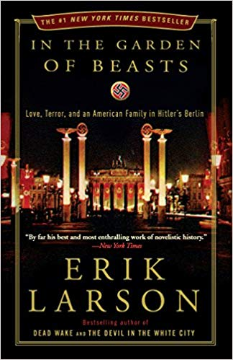

A mild-mannered professor from Chicago, Dodd brings along his wife, son, and flamboyant daughter, Martha. At first Martha is entranced by the parties and pomp, and the handsome young men of the Third Reich with their infectious enthusiasm for restoring Germany to a position of world prominence. Enamored of the “New Germany,” she has one affair after another, including with the suprisingly honorable first chief of the Gestapo, Rudolf Diels.
But as evidence of Jewish persecution mounts, confirmed by chilling first-person testimony, her father telegraphs his concerns to a largely indifferent State Department back home. Dodd watches with alarm as Jews are attacked, the press is censored, and drafts of frightening new laws begin to circulate. As that first year unfolds and the shadows deepen, the Dodds experience days full of excitement, intrigue, romance—and ultimately, horror, when a climactic spasm of violence and murder reveals Hitler’s true character and ruthless ambition.
Suffused with the tense atmosphere of the period, and with unforgettable portraits of the bizarre Göring and the expectedly charming--yet wholly sinister--Goebbels, In the Garden of Beasts lends a stunning, eyewitness perspective on events as they unfold in real time, revealing an era of surprising nuance and complexity. The result is a dazzling, addictively readable work that speaks volumes about why the world did not recognize the grave threat posed by Hitler until Berlin, and Europe, were awash in blood and terror.

“By far his best and most enthralling work of novelistic history….Powerful, poignant…a transportingly true story.” —New York Times

